NextJs14 and Shadcn UI Project

Project Directory: f:/nextjs14-shadcn

1. **Create project**

Start by creating a new Next.js project using create-next-app:

***npx create-next-app@latest my-app --typescript --tailwind –eslint***

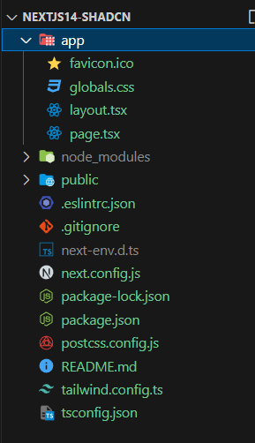

1. **Run the CLI and Configure comopents.jason**

Run the shadcn-ui init command to setup your project:

***npx shadcn-ui@latest init***

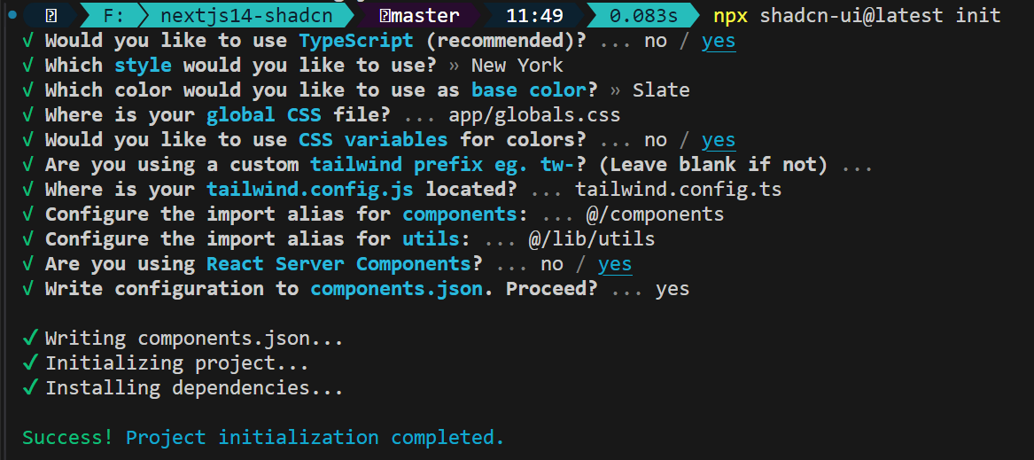

1. Adding Shadcn UI components to the project

npx shadcn-ui@latest add

Select all components individually by pressing arrow key and spacebar

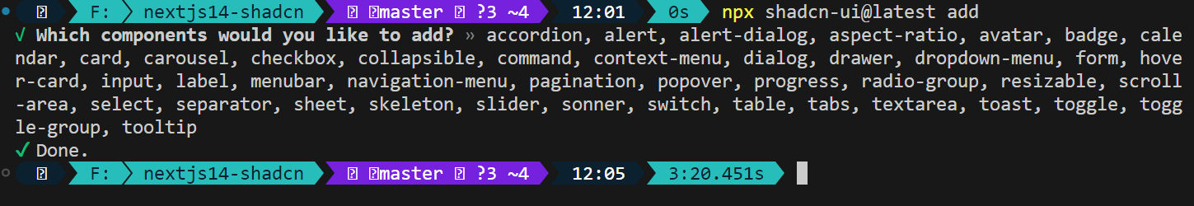

Once done it adds a component/ui folder to the project directory, the ui folder contains all components from shadcn:

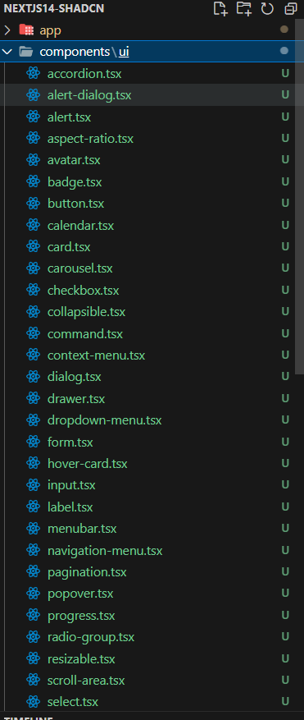

First run of the project

Before running the project modify code in page.tsx in the app directory to look like this:

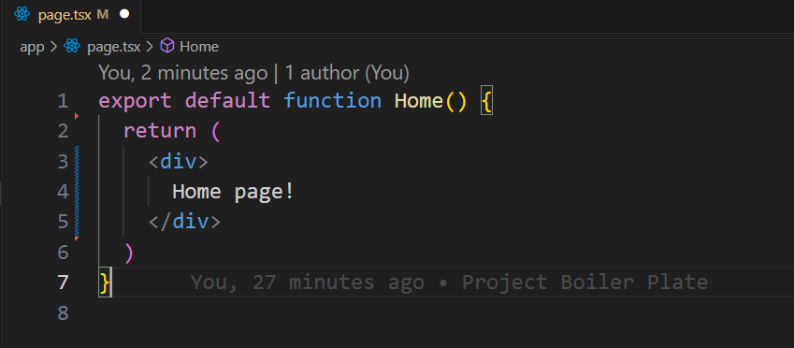

In the terminal run: npm run dev

Go to localhost:3000 following page will load.

Let us confirm that tailwind is working  
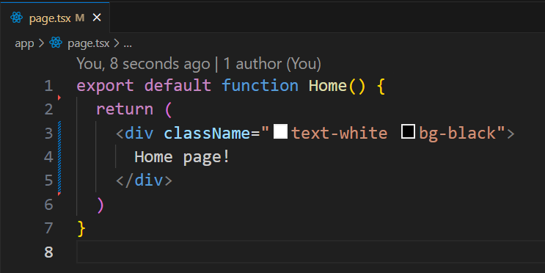

If the page in the browser looks like this tailwind is configured correctly and working

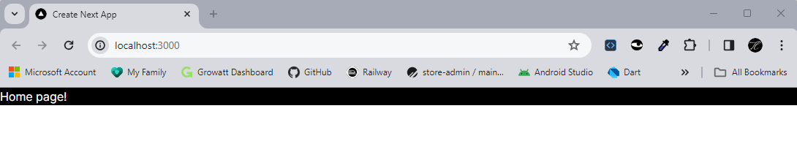

Let’s confirm shadcn is working by adding a button component from shadcn components

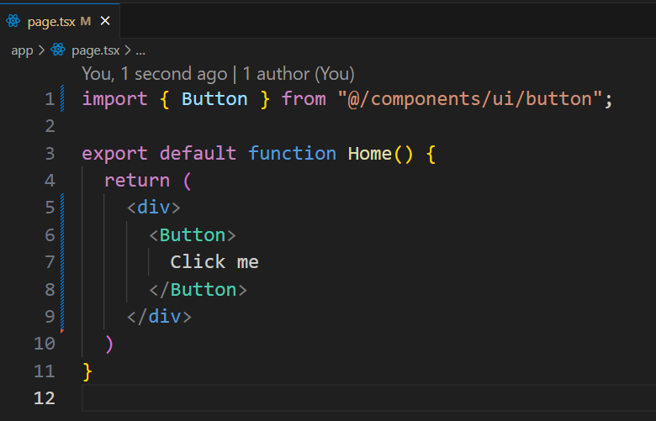

If you see following shadcn is also working ok

_______

Add a folder name “config” to the project create a file site.ts with the following code:

Added date format and absolute url functions to the /lib/utils.ts file

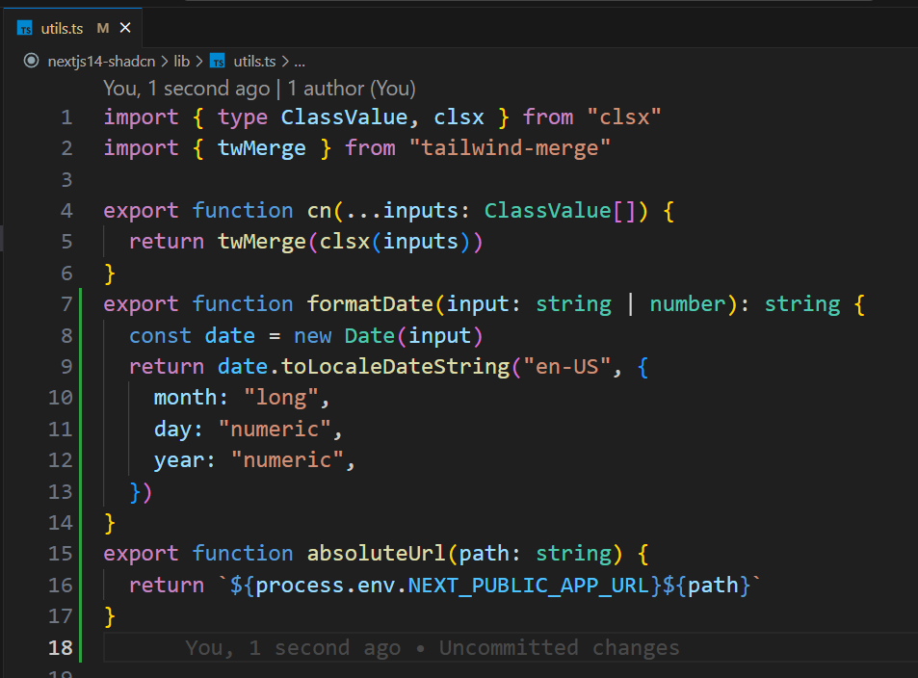

Create Custom Components for project.

Create a folder named “custom-components” in the project components folder.

Create 1st Custom Component:

Create a file named “announcement.tsx” in the “custom-components” folder just created.

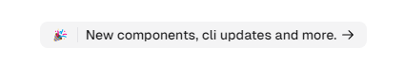

The code in announcement.tsx file should look like this

